Script it up Documentation
AI Techniques
AI Techniques for this assessment in were written in Python 2.7, all AI techniques are standalone functions found in the “Behaviors” module. Currently only two behaviors are defined.
SEEK
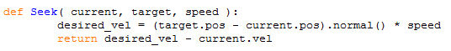
The seek function takes in two arguments: current which is the sprite (or any object with a valid position and velocity) that will be seeking the target sprite. The speed argument is simply a coefficient that determines how fast the current sprite will be seeking. The seek function determines the direction (velocity) that the current sprite is to take by normalizing the difference between the current sprite and the target sprite’s positions and then multiplying it by the speed argument, the resulting value is then returned.
To actually apply seek, simply add the value returned by seek to any sprite/valid moving object’s velocity each frame in the game’s update loop.
ARRIVE
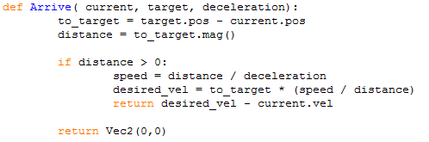
The arrive function is nearly identical to the seek function in behavior; except as the current sprite nears its target, its velocity gradually decreases until it comes to a halt when it reaches its destination.
The application of arrive is the same as seek.
Potential Improvements
- Move current behaviors and future developed behaviors into some kind of behaviors class to accentuate a more object oriented design.
- Develop more behaviors.
Non-Implemented AI Techniques
Flee, Pursuit, Evade, Wander, Avoid Obstacle, Interpose, Hide, Follow path

